**IMPALING IN MINECRAFT**

In this article, you will come to know **what does impaling do in Minecraft.** Minecraft is a famous 3-D video game that is worldwide popular. It is famous for its **creation of SMP life.** It is an educational type of game for kids and a non-violent game can teach programming skills.

Impaling is **an enchantment for a trident**, causing the trident to deal extra damage on each hit against aquatic mobs‌, or extra damage to mobs in water‌. The Impaling enchantment **increases your attack damage against sea creature mobs** such as guardians, elder guardians, squids, dolphins, and turtles. You can add the Impaling enchantment to any trident using an enchanting table or anvil. Then use the enchanted trident to fight a sea creature mob and see just how quickly you can kill it. Minecraft has multiple different enchantments, with a new one seemingly being added with each large update.

Impaling is an enchantment that players can place only on the trident in Minecraft. The trident is a powerful weapon in Minecraft that players must go into the water to obtain. This weapon can only be obtained by defeating a drowned.

Drowned mobs are zombie mobs that have drowned underwater and been converted to drowned zombie mob that lives underwater. Only a few of the drowned mobs carry the trident, so players will just have to get lucky.

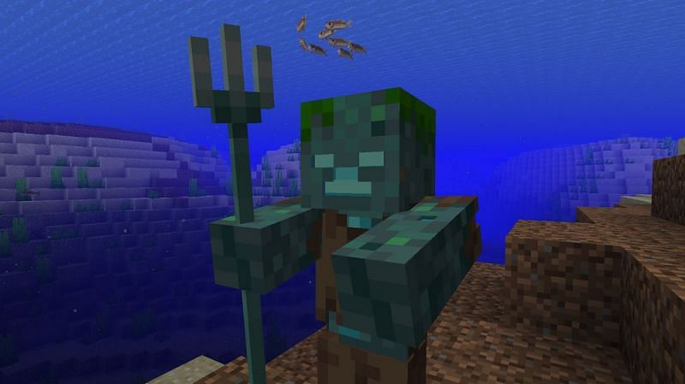

**WHAT IS IMPALING ENCHANTMENT?**



The impaling enchantment in Minecraft causes tridents to deal more damage to aquatic creatures. The way that the impaling functions differ between the Java Edition and the Bedrock Edition.

In the Java Edition, only aquatic mobs receive extra damage, which does not include regular mobs that happen to be in the water.

These include:

* Dolphins
* Guardians
* Elder Guardians
* Squid
* Glow Squid
* Turtles
* all fishes
* axolotls

Drowned also do not receive the extra damage, as they are considered an undead mob instead of an aquatic mob.

In the Bedrock Edition, the extra damage can be dealt with by all mobs and players that are in contact with water. This includes mobs and players that are in the rain. This means that this enchantment is only useful for those around water and, therefore, doesn't work in the same way as some other offensive enchantments do. For example, the Sharpness enchantment increases a player's melee damage generally while the Bane of arthropods enchantment in Minecraft increases damage against the in-game arthropods only.

**WHAT DOES IMPALING DO ACTUALLY?**

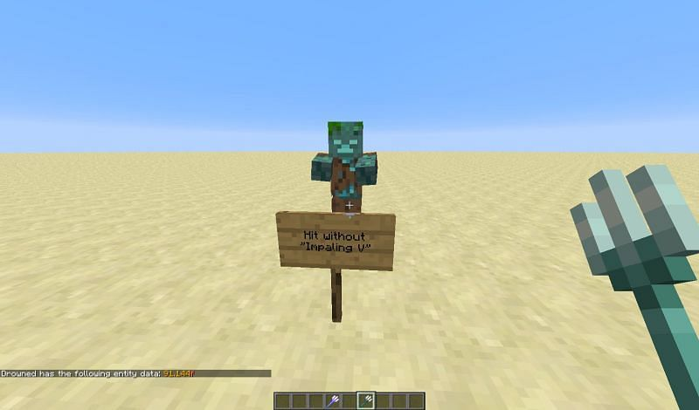

Impaling is an enchantment in Minecraft that allows players to deal additional damage to underwater mobs in the game. Impaling is good when a player is exploring underwater structures like ocean monuments or even when trying to obtain **additional tridents from drowned mobs.**

If a player already has a trident but is looking for more, using a trident equipped with impaling will help fight off the drowned mobs faster and more efficiently. Players will be able to slay a group of drowned mobs and look for tridents faster if they already have a trident with impaling attached to it. Mobs will die quicker with each hit, and it will not take the player long to defeat the group.

**HOW TO EQUIP?**

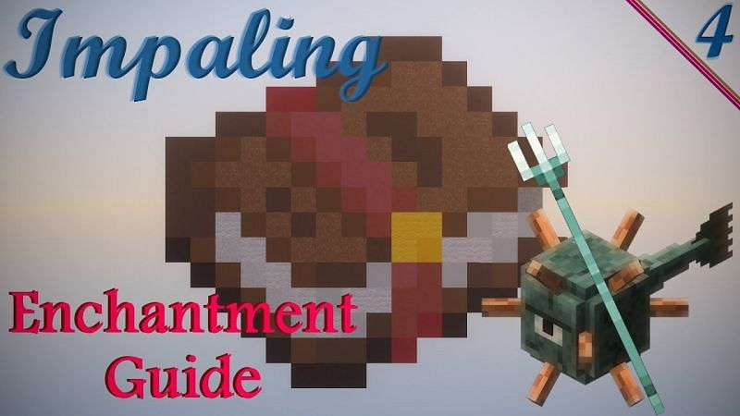

The impaling enchantment can be applied to any trident using an anvil or an enchanting table. Both of these items are easy to create and easy to operate as well. Anvils are crafted using three iron blocks and four iron ingots. Players will just need levels of enchantment and an enchanted book of impaling to place the enchantment on the trident using the anvil.

Enchanting tables are crafted using four blocks of obsidian, two diamonds, and one book. Players will need lapis lazuli and enchantment levels to use the enchanting table.

**CONCLUSION:** I hope this article helps you a lot about **what does impaling do in Minecraft.** Impaling increases the power of a trident and increases the damage level while killing with a trident. And this article also gives information about **impaling and how to equip it.** Share the article with your friends and have fun in the game.

***Article by,***

***Noone Harshan***

***+919550949044***